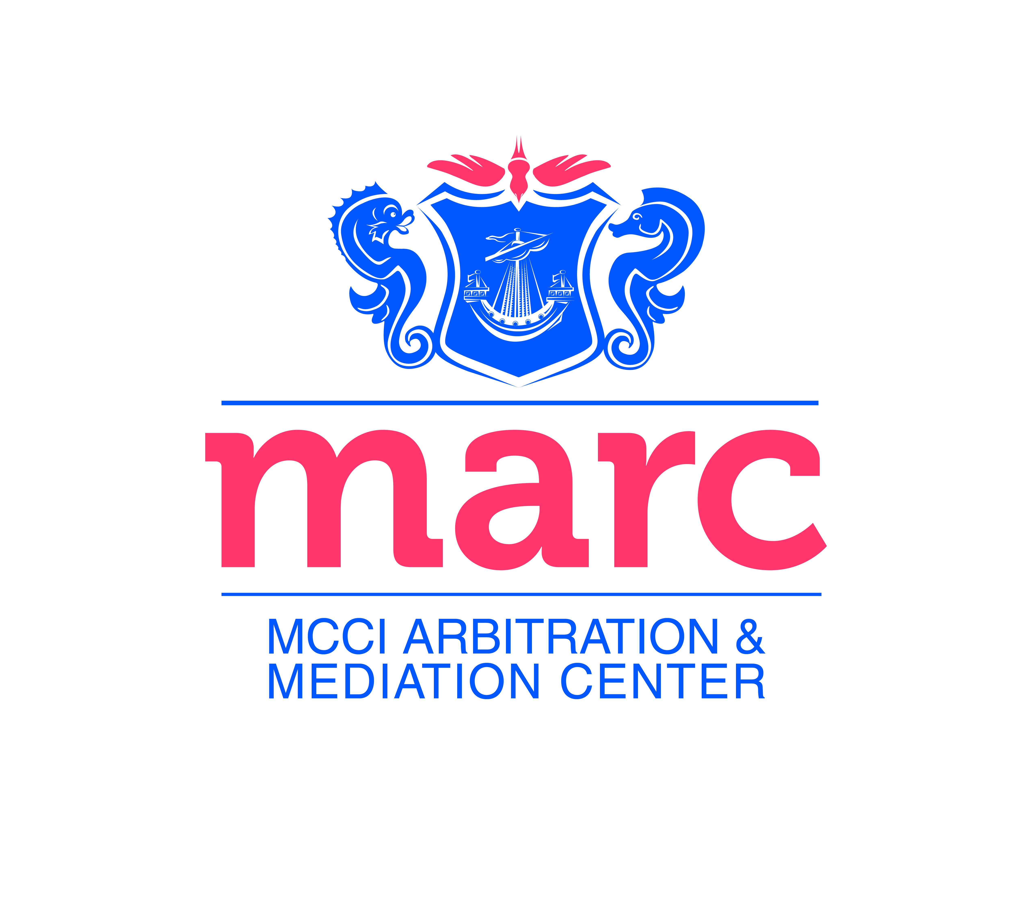

MARC 45
Application Form

Please complete the registration form and return it to the MARC via the following channels:- by Post: c/o MCCI, 2nd Floor, Anglo-Mauritius Building, 6, Adolphe de Plevitz Street, Port Louis OR by Fax: (230) 208 00 76. For further enquiries, please contact the MARC on 230 203 48 30 or Email: marc@mcci.org

Title: Mr. Mrs. Ms. Dr. Prof.
Other, please specify:................................................................................
Family Name: __________________________ Given Name: _____________________
D.O.B ___________________________________________
Company/Firm: _______________________________________________________________
Profession: __________________________ Job title: ___________________________
Address:________________________________________________________________
Tel:________________ Fax:_________________ Email:________________________
Please attach a copy of your resume or email it to marc@mcci.org.

I hereby agree to become a member of MARC45.

Signature:_________________________________

MARC45 is the group for young lawyers and arbitration practitioners in Mauritius and beyond.
We aim to promote the use of arbitration for better business and economic development, to promote Mauritius as an arbitration seat as well as to provide a platform for members to learn from each other.
Join us on this challenging endeavor and become a member of MARC45. Membership is dedicated to lawyers and other arbitration enthusiasts under 45.

