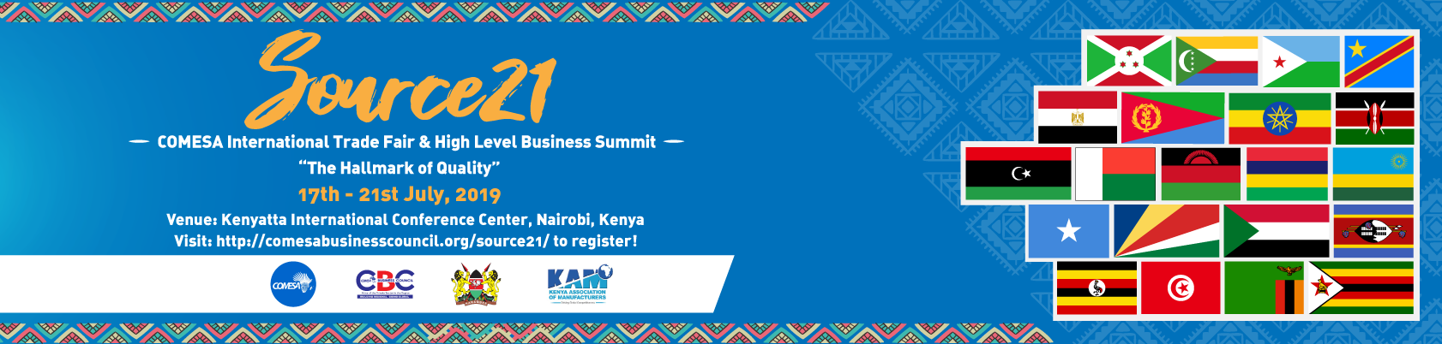
SOURCE 21 COMESA INTERNATIONAL TRADE FAIR AND HIGH-LEVEL BUSINESS SUMMIT
REGISTRATION FORM

All delegates and any accompanying persons are required to complete the registration form in full. Please photocopy this form for additional delegates. be paid in full before the event. Delegate fees must
FEES STRUCTURE (tick relevant box)
- Region tick relevant box)- ✔FEES LIST COUNTRY
BUSINESS SUMMIT
International |  | US$300.00
Regional Delegate: EAC, SADC, COMESA, Rest of Africa |  | US$250.00
Kenyan Delegates – Nationals | × | Free | Kenya
EXHIBITORS |  |  | COUNTRY AND PRODUCTS
National company/association/ Organisation/SMEs |  | US$1000.00for a 3m by 3m booth
Multi-National/Regional company/association/  Organization based in Kenya |  | US$1,500 for a 3m by 3m booth  US$1,900 for a 3m by 6m booth
Regional company/association/ Organization |  | US$1,500 for a 3m by 3m booth  US$1,900 for a 3m by 6m booth
International company/association/ Organization |  | US$1,500 for a 3m by 3m booth  US$1,900 for a 3m by 6m booth

SOURCE 21 COMESA INTERNATIONAL TRADE FAIR  EXHIBITORS |  |  | COUNTRY AND PRODUCTS
National company/association/ Organisation/SMEs |  | US$1000.00 for a 3m by 3m booth
Multi-National/Regional company/association/ Organization based in Kenya |  | US$1,500 for a 3m by 3m booth  US$1,900 for a 3m by 6m booth
Regional company/association/ Organization |  | US$1,500 for a 3m by 3m booth  US$1,900 for a 3m by 6m booth
International company/association/ Organization |  | US$1,500 for a 3m by 3m booth  US$1,900 for a 3m by 6m booth
CBC MEMBER RATES(PAID ONLY)
Exhibition Stands—Business Association |  | US$1,000.00 for a 3m by 3m booth
Exhibition Stands—Corporate |  | US$1,200.00 for a 3m by 3m booth  US$1,500 for a 3m by 6m booth

PERSONAL DETAILS
Title
Surname
First Name
Organization
Position
Address
Post Code
Country, State
Telephone Number; Mobile
Fax Number
Email Address

PAYMENT OPTIONS
BANK NAME: | Standard Chartered Bank
BRANCH: | Lusaka Main Branch
A/C NAME: | COMESA BUSINESS COUNCIL
A/C NUMBER: | 8700213716700
BRANCHCODE: | 060017
SWIFT CODE: | SCBLZMLXXXX
IMPORTANT: Kindly send proof of payment, quoting your name, bank address, swift code and account number.- Kindly note that all transfer costs should be beared by sender- and not beneficiary.

Signature:……………………………………… Date…………………………………………

This registration form should be sent to: NImwiko@comesa.int ; kmadzivanyika@comesa.int ; comesabusinesscouncil@comesa.int
For Kenya National registration, kindly register through the Kenya Association of Manufacturers at kamconsulting@kam.co.ke

