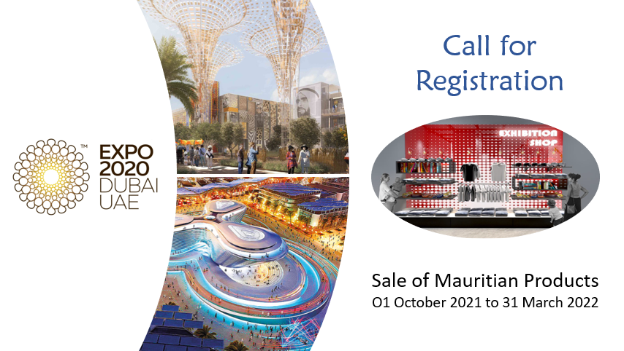
Commercial Activities during Dubai Expo 2020 (O1 October 2021 to 31 March 2022)
On 01 October 2021, the doors of Expo 2020 Dubai will open for six months, welcoming some 25 million people from around the world to an experience like no other, 70% of which are expected to be from outside of the United Arab Emirates. With its theme, ‘Connecting Minds, Creating the Future’, Expo 2020 Dubai will illustrate that together we are creating brighter and smarter ideas for a better future for all. Expo 2020 will transport visitors to new worlds through immersive pavilions whereby some 192 participating countries will showcase the best each has to offer: their innovations, world-class architecture, captivating storytelling, live performances and much more.
Inspired by its subthemes of Opportunity, Mobility and Sustainability, Expo 2020 will be an opportunity for discovery and personal enrichment. The pavilion of the Republic of Mauritius, with the theme “Roots of the Future”, will be positioned in a prime location in the Opportunity District, near the Al Wasl Plaza which represents the heart of the Expo site and the UAE Pavilion which is expected to attract a maximum number of visitors during the event.
The Expo 2020 represents a good platform for the Republic of Mauritius to showcase its economic vibrancy, socio-political stability and cultural heritage, and promote the country’s brand to foster trade, investment and tourism growth objectives. Several events such as Business Forums, Buyers Sellers Meetings, B2B meetings, fashion shows and cultural shows will be hosted during the Expo 2020 Dubai with a view to enhance the reputation of the Republic of Mauritius as an attractive investment and business centre, a competitive export platform as well as an International Financial Centre (IFC) of substance and more importantly as a cultured destination of choice for travel and leisure.

Commercial Activities
Expo 2020 Dubai’s commercial activities are enriched by the participants’ contributions, allowing visitors the opportunity to experience regionally authentic products. The event aims to create a powerful connection with its visitors through the range of products offered for sale by participants’ commercial activities. Inspired by Expo 2020 Dubai’s theme and supporting the subthemes, the participants’ commercial activities will provide a unique touchpoint for visitors to engage, elevating the overall visitor experience. Participants will have the opportunity to contribute to the success and diversity of the overall commercial activities across the Expo site through Exclusive Food, Beverage and Retail Offerings within their pavilion, commercial kiosks and digital platforms.
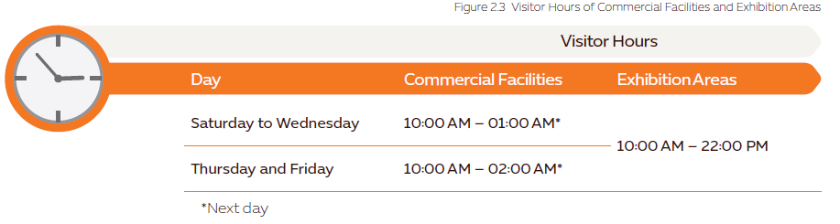
In this context, local manufacturing companies will have the opportunity to showcase their talent, culture and resources on a global platform and increase engagement with visitors in two dedicated commercial spaces: within the Pavilion of the Republic of Mauritius and in the Expo World Market through the allocated space area of 9m² and 13m² to the Republic of Mauritius respectively. Sales of Mauritian products will be done throughout the six months of the Expo. This will indeed represent an opportunity for the Republic of Mauritius to position itself as a reliable sourcing destination through its product offering in the two commercial spaces.
To qualify for sales of Mauritian products at Expo 2020 Dubai, the EDB will have to submit a Commercial Proposal to the organiser.
Main content of the Commercial Proposal
- To cover the requirements for Food & Beverage and/or Retail Operations
- Showcase culturally significant and unique products of the country
- Detailed overview of the type of commercial activities to be operated within the allocated space and online
- List of products and services to be offered including type, price, labelling, and packaging of the products to be sold
- Proposed management structure including staffing requirements
- Environmental considerations to be implemented across the commercial activities, taking sustainable sourcing into consideration and showcasing environmentally sustainable products (e.g. cloth/paper bags, no plastic wrapping)
- Other operational details supporting the commercial activities
Products within Commercial Kiosks
Participants are encouraged to adopt the following guiding principles for products they intend to sell as part of their World Market initiative. These are products that are:
- Truly representative of a participant’s culture and are connected to the participant’s exhibition
- Sourced and produced in the country of origin
- Support low-income earning artisans/communities/families
- Utilising small and medium enterprises (SMEs), showcasing the design capabilities, manufacturing techniques, and quality workmanship available in the country of origin
- Sourced ethically
Note: Sale of alcoholic food and beverages are not permitted in the Expo. However, the companies can market these products during the Buyers and Sellers Meetings (B2B only).
Packaging and Labelling (section 3.2.2 of the Commercial Guide)
C-19: Participants must ensure that their product packaging and/or labelling is in accordance with the requirements of the laws and regulations of the UAE. For details on packaging and labelling requirements, see the Logistics and Customs Guide and the Food and Beverage Guide for Self-Built Pavilions and Rented Pavilions.
In line with Expo 2020 Dubai’s commitment to sustainability, participants need to consider the efficiency and requirement of any packaging for their products. If packaging is deemed necessary, participants are encouraged to select materials from sustainable sources and provide details with regards to the recyclability of the packaging.

Product Pricing (section 3.3 of the Commercial Guide)
As an inclusive event, Expo 2020 Dubai aspires to have a diverse range of products that care not only to everyone’s taste but also to their budgets. Participants are encouraged to offer visitors value for money and to ensure that the prices of their products are aligned with the current market value.
As part of the commercial proposal, Participants are required to submit indicative prices for their products to ensure alignment of pricing across the Expo site. Participants are also encouraged to offer a product range with a variety of price points suitable for different visitor groups.
C-20: Participants must clearly display the price of the goods and services that they offer including additional or incorporated taxes such as VAT. All prices must be displayed in Emirati dirham (AED), the national currency of the UAE.
Guidelines set by Dubai Expo 2020 for Commercial Activities
The following guides have been developed by the Organiser to provide participants with the necessary information they need conducting commercial activities. You are kindly requested to go through the Commercial Guide and relevant sections in the other related guides and special (kindly click on link below) prior to submitting your application:
- Commercial Guide
- Customs Guide
- Food & Beverage Guide
- Logistics Special Regulation 7
- Special Regulation 9
Some important articles include:
Commercial Guide
- Section 1.3: Consumer Protection (figure 1.2: UAE Consumer Protection Law)
- Section 2.1: Commercial Journey
  - Section 2.1.2: Commercial proposal
  - Section 2.1.3: Retail-in-a-Box Point-of-Sale-System
  - Section 2.1.5: Inspection prior to opening
- Section 2.2: Licencing and Registration
  - The Expo 2020 licence will be provided to the EDB
- Section 2.9: Royalties
- Section 3.2: Product
- Section 3.2.3: Packaging and Labelling
- Section 4.3: Sustainability
- Section 4.4: Waste Management
Logistics and Customs Guide – Section 2.1.2: Transportation Plan
Special regulation 7, Article 19:
All goods and products imported by participants and sold in the UAE shall be subject to applicable customs duty and import VAT based on different categories of goods
All goods and products sold in the commercial activities shall be subject to applicable sales VAT
Note: The participant in the Guide refers mainly to the Economic Development Board which has the responsibility of coordinating with local manufacturing companies.
Procedure for Registration
Local manufacturing companies are hereby invited to register their interest to sell products during the Expo in the pavilion of the Republic of Mauritius and/or the Expo World Market by updating the attached registration form and e-mail to V.Guddye@edbmauritius.org and imrane.mulbocus@edbmauritius.org at latest by 16 October 2020.
You are kindly requested to detail your product offering by mentioning how your product meet the guiding principles of the organiser.
Please ensure to attach the photos of your products and provide a copy of the certifications (ISO, HACCP etc.). For companies not registered with the EDB, kindly provide a copy of your BRN and incorporation.
The registration form has been designed to obtain all necessary information on the product for the development of the Commercial Proposal and Product Catalogue to be submitted to the Organiser.
Note for Food & Beverage: Unfortunately, due to limited budget and space, it has not been planned to offer food and beverage in the Mauritian Pavilion during the event. However, culinary activities will be planned during the Mauritius Week and companies from the Food & Drink sector might be requested to participate through provision of their products for tasting and menu preparation.
Approval process for participation:
- A first selection of company/products will be conducted at the level of Business Committee which is a sub-committee of the Republic of Mauritius Organising Committee for the Expo Dubai 2020
  - The Business Committee includes members of institution such as: SME Mauritius, Business Mauritius, MCCI, MEXA, AMM, Ministry of Rodrigues, Outer Islands and Territorial Integrity
- Submission of the Commercial Proposal by the EDB to the Organiser for final approval and validation
- Final selection of products will be undertaken by the Organiser
- A meeting will be held with the selected companies to explain the modalities for shipment of products, mode of payment, conditions for participation, determination of retail price (customs duty applied, VAT in Dubai, royalty fee to D2020 etc.)
- The final retail price for each product will be finalised with the Organiser taking into considerations all VAT (5%), custom duty (5%), royalty fee (10%), costs associated with the sales in the Expo and any associated costs incurred with the facilitation of the payments via the online stores if applicable (not yet finalised)
- The company will have to sign a Participation Agreement with the EDB to confirm its commitment to engage in the commercial activity during Expo 2020 Dubai

Selection Criteria at the level of the Business Committee:
The main criteria to be used to qualify the company and its products for sale include:
- Product to undergo at least a value-addition of 35%
- Export-readiness of company
- Quality of product and packaging
- Production capacity
- Commitment from company to participate as per guidelines set by the organiser and conditions set by the EDB
- Product offering is in line with the Mauritian theme and Dubai Expo 2020 theme

General Remarks
Companies will also have the possibility to distribute Promotional Giveaways to visitors. You are kindly requested to express your interest in the distribution of giveaways during the expo or in hosted events by the EDB and give an indication of the product and quantity.

Responsibilities of the EDB:
- To finalise the list of companies and products with the Business Committee
- Submit the Commercial Proposal to Dubai Expo 2020 within the set deadline
- Appoint service provider for the shipment of products (by sea) to Dubai Expo 2020 as and when required during the six months of the expo (All shipment costs to be borne by the company)
- Analyse sales and forecast shipment for the coming months
- Liaise with the organizer of Dubai Expo 2020 for the clearance, transportation and handling of goods
- Appointment of Salesperson in the pavilion of the Republic of Mauritius and Commercial Kiosk
Terms & Conditions:
- All the information in the registration form should be provided within the set deadline
- All products need to be manufactured in the Republic of Mauritius with a minimum of 35% of value-addition
- Members of the Selection committee may conduct a visit to your company or request for samples of your products if deemed necessary
- Each company selected to have its products on sale will have to participate in Buyers Sellers Meeting to be organized during the Dubai Expo 2020 in their respective sector if required
- The company will have to ensure that products are sent for replenishment of stock as and when required during the 6 months of expo
- All shipments will be done through the EDB’s Logistics Coordinator only and each company will have to bear the cost of shipment for its products
- Commercial space will be allocated on a rotation basis depending on the number of companies/products registered/approved for sale
- Large companies (with annual turnover >MUR 50 million) will have to pay listing fee of MUR 25,000 for each different product to the EDB
  - All companies must provide a copy of the latest financial statement together with their application
- Payment to the company will be done by the EDB within one month after receipt of fund from the Dubai Expo Organiser
- Products need to have a barcode since all sales and stock will be monitored via the Retail-in-a-Box Point-of-Sale-System (refer to section 2.1.3 of the commercial guide)

For more information, please contact Mr. Vinay Guddye on 203 3828 or Mr. Imrane Mulbocus on 203 3314 and/or on e-mail V.Guddye@edbmauritius.org or imrane.mulbocus@edbmauritius.org

